**EX:2 WEB PAGE DESIGN**

**THEME: 7 WONDERS**

**OUTPUT SCREENSHOT:**

**DEMO VIDEO LINK:** [**VIDEO**](https://clipchamp.com/watch/2qs926p5DXD)

**HOME PAGE:**

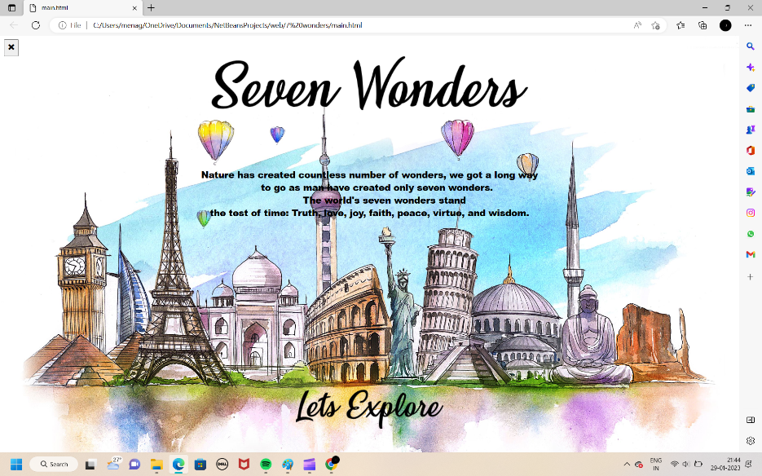

New web page with list of options will be open when user click the “lets explore icon”

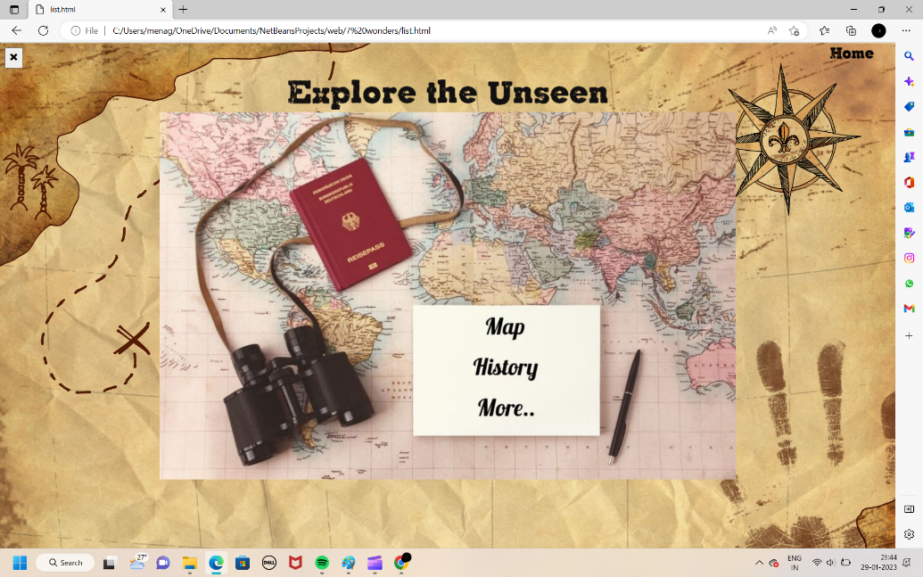

When the user click the map, the new hodophile’s spot page will get displayed

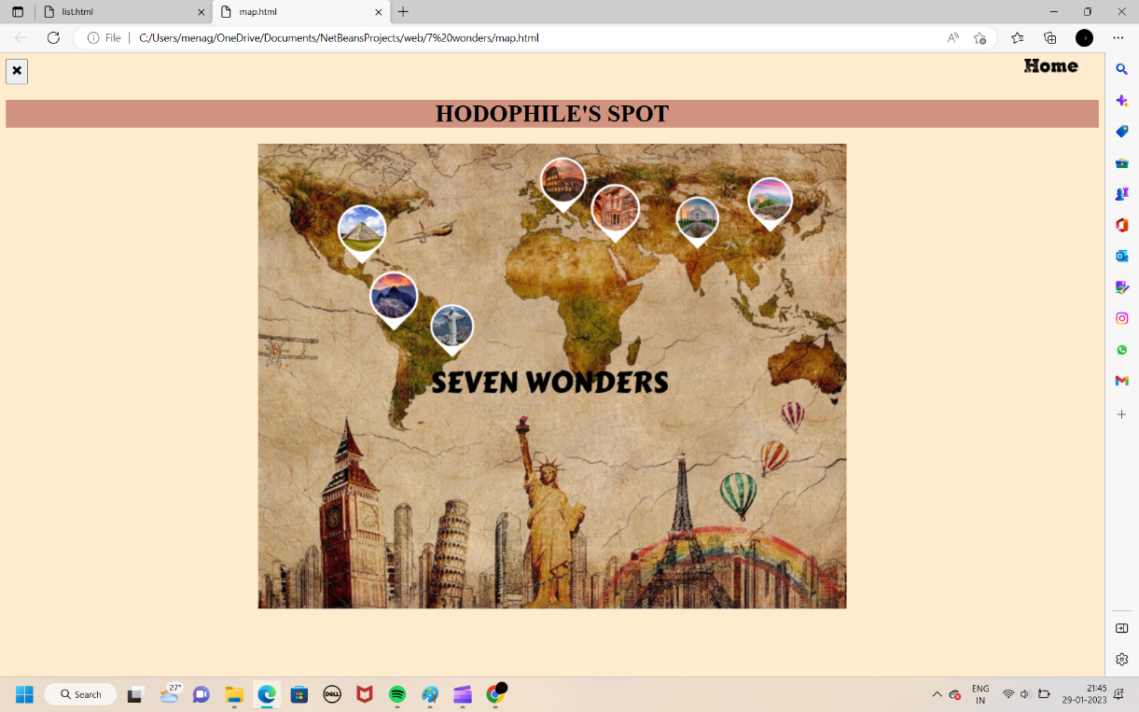

When the user clicks the history option the new web page will be displayed with the list of 7 wonders

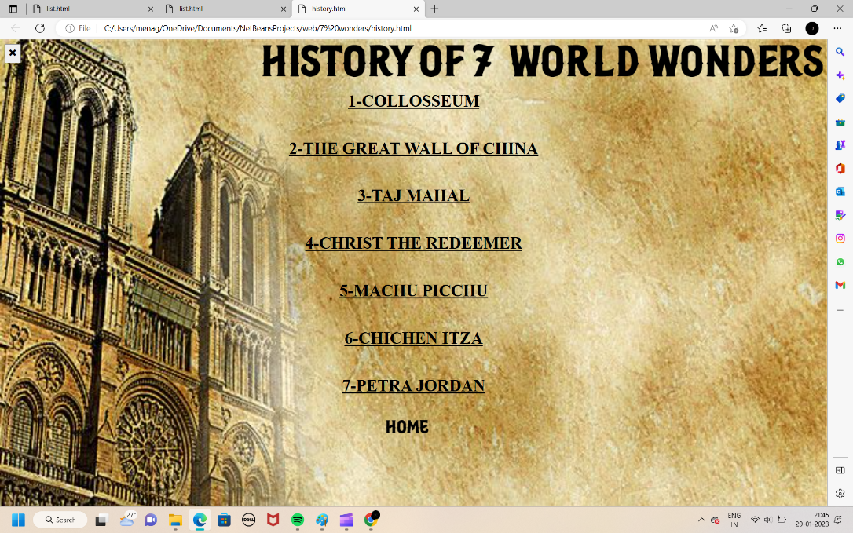

Web pages for displaying the history of the 7 world wonders:

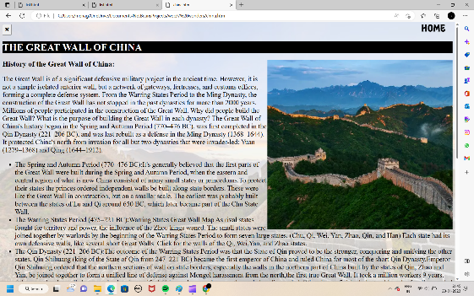 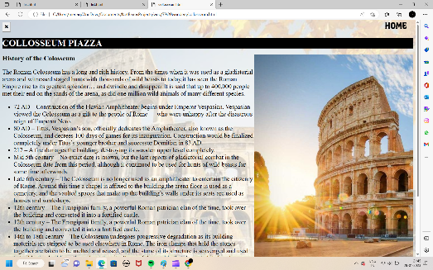

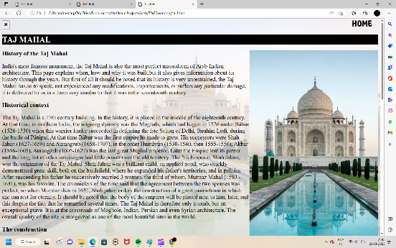 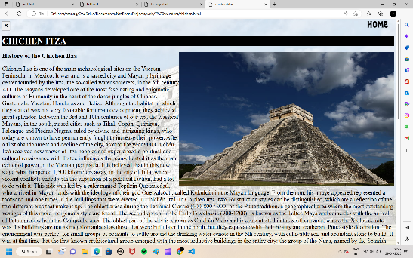

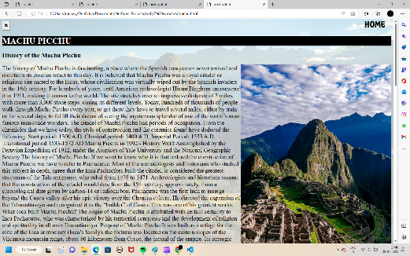 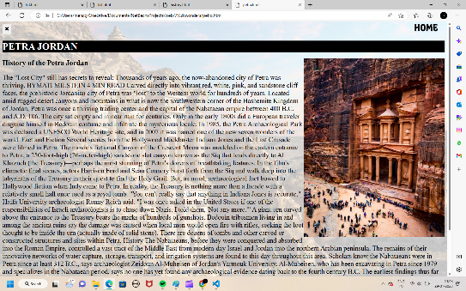

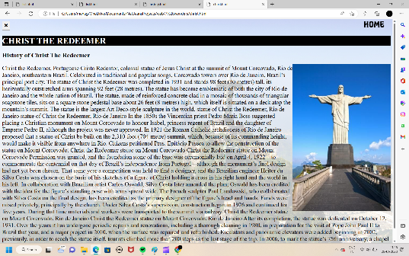

When the user clicks the more on the option list the new web page with the travel tips will be get displayed with video clips of 7 world

